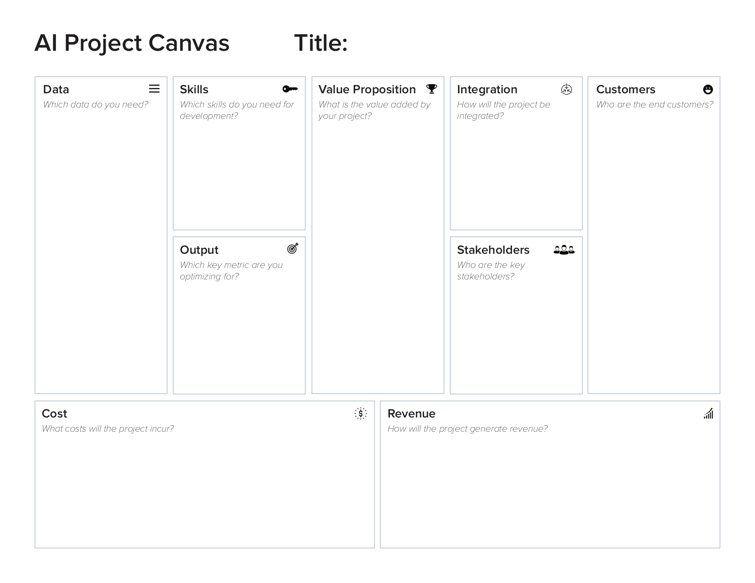

The management will, thanks to this project, see in what show they can put more money in.

The management

Machine learning

Computer vision and programming skills.

None.

This project will provide insight in the amount of people that watch each show.

The management of Banijay.

Data from Twitter and ratings from shows.

Generating revenue and looking how many people watch a show at what time.

Banijay productions